Assignment #5 Machine Ready

After completing this pre-work module, you will have each of the following installed:

* Google Chrome
* Screencastify
* Slack
* Visual Studio Code
* "Open in Browser" Visual Studio Code extension
* Git
* Git Bash (Windows)
* Heroku Toolbelt
* Node.js
* MAMP

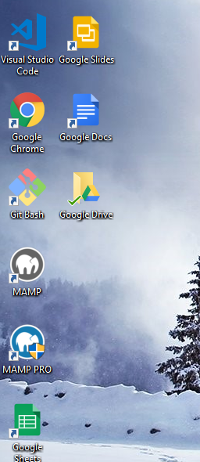

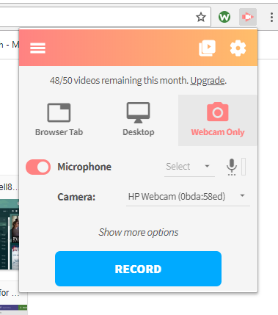



In addition, you will also have accounts on each of the following websites:

* LinkedIn
* GitHub
* Stack Overflow
* Slack